Andree Salvo
Southern New Hampshire University
CYB 400-13022
Instructor: Raschid Muller
8-2 Cyber Playbook Submission

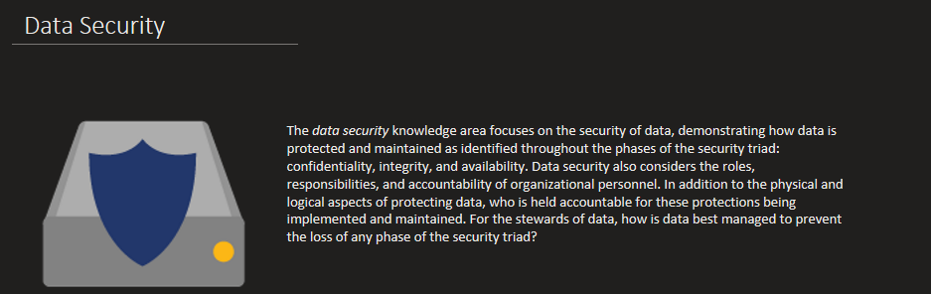
Data Security is the most valuable to me as it emphasizes the importance of protecting data through the principles of confidentiality, integrity, and availability. This area highlights not only the technical side of securing data but also the accountability and responsibility of organizational personnel in maintaining these protections. This is very important to me because understanding how to manage and safeguard data is critical in preventing breaches and ensuring trust within an organization. As a cybersecurity student, this concept reinforces my knowledge in developing strong data protection strategies and upholding ethical responsibility in safeguarding sensitive information.

